Software Requirements Specification
Version 1.5
Document Control
Approval
The Guidance Team and the customer shall approve this document.
Document Change Control
Initial Release: | 1.0
Current Release: | 1.6
Indicator of Last Page in Document: | ∑
Date of Last Review: | 4/25/2013
Date of Next Review: | 4/25/2013
Target Date for Next Update: | 4/25/2013
Distribution List
This following list of people shall receive a copy of this document every time a new version of this document becomes available:
Guidance Team Members:
Dr. Ann Gates
Omar Ochoa
Luis Garcia
Customer: Dr. Deana Pennington and Dr. Salamah Salamah
Software Team Members: Joseph Aguirre
Andre De La Cruz
Arturo Delgado
Juan Rodriguez
Jesus Tabares
Change Summary
The following table details changes made between versions of this document

Version | Date | Modifier | Description
1.1 | 4/15/2013 | Andre | Added General Constraints, Assumptions
1.1 | 4/16/2013 | Arturo | Added Intro and Scope
1.2 | 4/20/2013 | Andre | Modified Section 2.4 and 2.5
1.3 | 4/22/2013 | Andre | Modified 3.1
1.4 | 4/24/2013 | Andre | Added section 2.3 and 2.5
1.5 | 4/25/2013 | Arturo | Added Section 1.3
1.5 | 4/25/2013 | Joseph, Juan | Added 3.1.2, added 1.4 and 4.1

Table of Contents
Document Control ii
Approval ii
Document Change Control ii
Distribution List ii
Change Summary ii
1. Introduction 5
1.1. Purpose and Intended Audience 5
1.2. Scope of Product 5
1.3. Definitions, Acronyms, and Abbreviations 5
1.3.1. Definitions 5
1.3.2. Acronyms 6
1.3.3. Abbreviations 6
1.4. Overview 6
1.5. References 6
2. General Description 6
2.1. Product Perspective 6
2.2. Product Features 7
2.3. Use Case 7
2.4. User Characteristics 8
2.4.1. Scientist 8
2.4.2. Database 8
2.4.3. General Public 8
2.4.4. Alert System 8
2.4.5. Datacenter 8
2.5. Use Case Scenarios 8
2.5.1. Describe Data Properties Use Case 8
2.5.2. Verify Datasets Use Case 10
2.5.3. View Datasets Use Case 15
2.5.4. Describe File Format Use Case 18
2.5.5. Analyze Anomaly Use Case 20
2.6. General Constraints 21
2.7. Assumptions and Dependencies 21
3. Specific Requirements 21
3.1. External Interface Requirements 21
3.1.1. General User Interfaces 21
3.1.2. Wizard Training Guide 21
3.1.3. Main Screen 22
3.1.4. Tracking 22
3.1.5. Sensor 22
3.1.6. Data Properties 22
3.1.7. Preference 23
3.1.8. Hardware Interfaces 23
3.1.9. Software Interfaces 23
3.1.10. Communications Interfaces 23
4. Behavioral Requirements 24
4.1. Same Class of User 24
4.1.1. Objects 24
4.2. Stimulus 24
4.3. Related Features 24
4.4. Functional 24
4.4.1. Scope 24
4.4.2. Pattern 25
4.4.3. Data Properties 25
4.4.4. File Format 25
5. Non-behavioral Requirements 26
5.1. Performance Requirements 26
5.2. Qualitative Requirements 26
5.2.1. Availability 26
5.2.2. Security 26
5.2.3. Maintainability 26
5.2.4. Portability 26
5.3. Design and Implementation Constraints 27
6. Other Requirements 28
6.1. Database 28
6.2. Operations 28
6.3. Site Adaptation 28
7. Appendix A Class Diagram 29
8. Appendix B State Chart 30
9. Appendix C Data Flow Diagram (DFD) 31

Introduction

Purpose and Intended Audience
The purpose of this document is to represent the results of the analysis phase. It serves as an anchor point against which subsequent steps can be justified. This document will also describe how the system should behave. The intended audience of this document is the guidance team, Dr. Pennington, and Dr. Salamah and as reference for our development team.

Scope of Product
The current system that research scientists are using to gather environmental data from various sensors across different geographical locations has been a problem for the scientist because the interface is difficult to use and the different proprietary formats that the sensor manufactures use. There has been a request by Dr. Pennington to improve the current system which evaluates, manages, and detects anomalies. The following is an excerpt from the taped Interview of Dr. Pennington conducted by Dr. Gates and the Software Engineering Students on February 19, 2013. Dr. Gates ask Dr. Pennington about the limitations of the current system and Dr. Pennington’s response was:

“The biggest one is that it is written and design and formulated for a computer scientist. It got a language of computer science, it got the interface that is relevant to computer science, talks about queries and codes and rules that's not the language of science. So it does what it needs to do but it is not useable by a scientist.”

Definitions, Acronyms, and Abbreviations

Definitions

TERM | DEFINITION
Alert | System sending a notification to the user to tell them of a new anomaly
Anomaly | Data that is received that is within the scope and falls outside of a pattern of a data property
Citizen Science | Citizens gathering data to research from their local area
CyberShare | Research group at UTEP
Data Property | Combination of scope and pattern
Dataset | The data retrieved from the sensors
Datum | Data that is expected from a single sensor reading
Datum Absence | The data does not exist within the specified scope
Datum Existence | The data does exist between the specified scope
Datum Universality | The data will always exist
File Formats
Guest User | User with limited privileges of the system
L | Timestamp used on the left side of the Scope
Metadata | Data about the sensors
Pattern | A high-level abstraction describing a commonly occurring property about a dataset
R | Timestamp used on the right side of the Scope
Registered user | User that has all privileges for the system. (Scientist)
Relation Response | The data will appear in response to relation datum
Scientist | People doing research trying to understand the world around us. Scientist will be referred to as a user of the system through the duration of the document.
Scope | Range of data subsequence that is being evaluated
Sensor | Instrument that measures certain types of data

Acronyms
TERM | DEFINITION
IR | Interview Report
OS | Operating System
SDAT | Software Developers for the Advancement of Technology
SRS | Software Requirement Specification
UTEP | University of Texas at El Paso
WADS | Weather Anomaly Detection System

Abbreviations
TERM | DEFINITION
App | Application

Overview
The remainder of this document includes the general description of the system and specific requirements that were followed for developing the system. The general description will discuss product perspective, features, users, constraints, assumptions and dependencies. The product perspective will talk about where the product fits within the larger system and the functionalities that will be provided by this product. Product features will discuss different things that the system will have. In this section a use-case diagram will be presented to highlight essential features of the system. User characteristics will highlight the type of users the system was designed for. General constraints will explain the factors that constrain the options of the development team including any organizational factors, hardware limitations or safety and security considerations. Assumptions and dependencies will list the factors that if changed, will affect the requirements of the SRS of the system, assumptions made, and any dependencies of the system. The specific requirements will explore the requirements that were used as a guideline to develop the system. The requirements will be divided into subcategories external interface requirements, behavioral requirements, non-behavioral requirements and other requirements. The external interface requirements will discuss requirements for interfaces among different components and their external capabilities, including all its users, both human and other systems. The behavioral requirements will discuss specific behaviors that will be required by the system in order to be functional to the user.

References

General Description

Product Perspective
This product will assist scientist who are interested in data properties which consist of a scope and pattern. These data properties with data sets from sensors will have certain protocols to detect anomalies. Detecting and monitoring anomalies is the primary feature of this system for the authorize users. Another important feature in our system is the creation and modifying a data property by the authorize user. The product will address some of the concerns from a previous model, such as taking into account of what type of users will be utilizing the system and their perspectives.

Product Features
The system will be displayed as a web-based application where scientist and guest users will be able to view graphical representation of the data properties. Scientist will be able to monitor data properties and manage anomalies. This section will contain the use case scenarios. The system will do following:
- The system will display datasets as a graph (line/bar) for the general public and scientist.
- The system will generate an alert (via email/text) when an anomaly is detected.
- The system will keep a history of anomalies and data properties.
- The system will allow a scientist to create, save, delete, and edit a data property.
- The system will parse a file format from the user.
- The system will have features to change an email, contact, notification type, affiliation and password.
- The system will contain a map that displays sensors and users shall be able to zoom in, zoom out and choose a region where sensors are located.
- The system will have a search engine to search for a particular sensor.
- The system will keep track of sensor metadata, scientist will have features to filter out sensors for specific information the scientist is looking for.

Use Case
The use-case models the actors of the system and the interactions between actors and the system. Each stick figure represents an actor which is someone or something that will use the system for a purpose. The circles in the diagram represent functionalities of the system. The lines represent the interactions. A line connected to an actor and functionality indicates that the actor uses the system for such functionality.

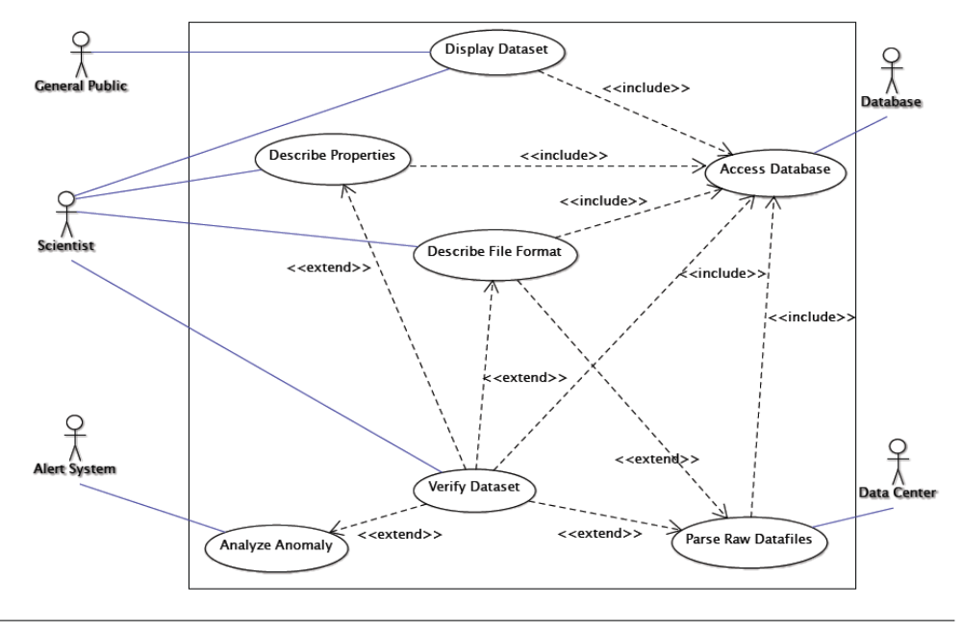
2.5.1.
2.5.2.
2.5.4.
2.5.5.
2.5.3.

User Characteristics

Scientist
The scientists are the individuals that will use the system to retrieve data to be analyzed. They are capable of displaying datasets which can be graphs, data from files, anomalies, or properties. However their access to information of the data may be limited to the property and data they created or were given access to by other scientist. The scientist will also need to describe the file format for external files that they want to analyze on the system. The scientist will also modify properties by creating pattern and scopes that the system will use. The scientist will also be able to set conditions for when an alert is triggered. The scientist will determine if the collected data should be accessible by the public.

Database
The database actor is the data store where all the information will be stored. It will be used to store information about the sensors and patterns such as the creator of the item as well as results from the analysis. It will be used by the system for scientist to store their properties, privileges to datasets, and alarm. It is also where saved information will be retrieved from.

General Public
The general public actor is representative of the general public that will have some limited access to the system as a part of the current trend of citizen science. The general public will only be able to view only datasets that the client will deem available to the general public, these users will not have the same privileges as a scientist and will not be able to describe a data property, describe a file format, parse a raw data file into a universal format, or verify a dataset.

Alert System
The alert system actor is the third party system that will be used to send alert messages to the scientist’s cell phones if they have configured the system to alert them via a cell phone text message. Dr. Pennington requested this feature during the first interview with the client.

Datacenter
The data center actor is used to represent a location where the data files from the sensors will be coming to the system. This actor will provide a raw data file to the system that is from a sensor and the system will then transform the file from the hardware specific file to a universal file that the system can analyze.

Use Case Scenarios

Describe Data Properties Use Case
Scenario 1: Create A New Data Property.
Include Use Case: Access Database.
Description: The Scientist describes a new data property to be saved to the database for later use.
Actors: Scientist, Database.
Pre-Condition: The scientist has logged on to the system and the scientist is a registered user of the system.
Trigger Condition: The scientist has chosen the option to describe a new property.

- The system displays a form where the scientist can specify a scope, a pattern, a data file they wish to associate the data property with, and any other general comments he/she may have.
- The scientist selects the save data property option.
- The System accesses the database.
- The database stores the user specified data property along with the scientist’s general information (i.e. name, number, place of study at the time, etc.) (Alt 1).
- The system informs the user that the property has been saved to the database.
- End of use case.

Alt 1: Property created already exists.
- The database generates a message to the system signifying that the specified data property already exists in the database.
- The system generates a message to the scientist that the specified data property already exists in the database and asks the user if they wish to view the property in the database.
- The scientist choses the option to view the data property (Alt 2).
- The system accesses the database to view the data property information.
- The database retrieves the data property information and sends it to the system.
- The system presents the user with the data property information.
- The scientist closes the presented data property information.
- End use case.

Alt 2: Scientist does not wish to view found property.
- The scientist choses to not view the data property information.
- End use case.

Scenario 2: Edit A Data Property.
Include Use Case: Access Database.
Description: The Scientist edits a data property that already exists in the database.
Actors: Scientist, Database.
Pre-Condition: The scientist has logged on to the system and the scientist is a registered user of the system.
Trigger Condition: The scientist has chosen the option to edit a property.

- The system accesses the database to get a list of data properties that are available for editing.
- The database retrieves the list of data properties and sends the list to the system.
- The system displays the list of data properties for editing and provides the user the choice to create a new data property (Alt 1).
- The scientist specifies the data property they wish to edit.
- The system accesses the database for the specific data property they wish to edit.
- The database retrieves the specified data property the scientist wishes to edit and sends it to the system.
- The system displays a filled in form containing the specified data property information.
- The scientist makes the needed changes to the data property and choses to save the changes.
- The system accesses the database to make the changes the scientist made.
- The database changes the appropriate fields to the new data specified by the scientist and logs the change and adds the scientist’s information into the use log.
- The system generates a message to the user that the changes have been made.
- The scientist exits the edit mode.
- End of use case.

Alt 1 Scientist chooses to create a new data property.
- The scientist choses to create a new data property.
- Continue execution at scenario 1, step 1.

Scenario 3: Delete A Data Property.
Include Use Case: Access Database.
Description: The Scientist deletes data property from the database.
Actors: Scientist, Database.
Pre-Condition: The scientist has logged on to the system and the scientist is a registered user of the system.
Trigger Condition: The scientist has chosen the option to describe a new property.

- The system accesses the database to get a list of data properties that are available to be deleted.
- The database retrieves the list of data properties and sends the list to the system.
- The system displays the list of data properties for editing and provides the scientist the choice to create a new data property or to edit a data property (Alt 1) (Alt 2).
- The scientist specifies the data property they wish to delete.
- The system accesses the database for the specific data property they wish to delete.
- The database retrieves the specified data property the scientist wishes to delete and sends it to the system.
- The system displays a filled in form containing the specified data property information.
- The scientist choses to delete the data property.
- The system confirms if the user would like to delete the data property.
- The scientist confirms the delete operation.
- The system accesses the database to delete the specified data property.
- The database deletes the specified data property.
- The system generates a message to the user that the data property has been removed.
- The scientist exits the delete mode.
- End of use case.

Alt 1 Scientist chooses to create a new data property.
- The scientist choses to create a new data property.
- Continue execution at scenario 1, step 1.

Alt 2 Scientist chooses to edit a data property.
- The scientist choses to edit a data property.
- Continue execution at scenario 2, step 1.

Verify Datasets Use Case

Scenario 1: Verify dataset with New Property, New Description, and New Dataset.
Include Use Case: Access Database.
Description: The Scientist wants to do a new analysis of a dataset with all new information
Actors: Scientist, Database.
Pre-Condition: The scientist has logged on to the system, the scientist is a registered user of the system, the scientist has selected the analyze button from a previous menu.
Trigger Condition: The scientist has chosen the following three options: new property, new file format, new dataset.

- Execution starts at Scenario 1, step1 (Alt 5) (Alt 6) (Alt 7) (Alt 8) (Alt 9) (Alt 10).
- The Scientist confirms to keep new property (Alt 1).
- Execution continues to Scenario 17, step 1
- The Scientist confirms to keep new file format (Alt 2).
- System displays file selector menu.
- Scientist selects file to be parse.
- Execution continues to Scenario 19 step 1.
- The Scientist confirms to keep new dataset (Alt 3).
- System enables the analyze button.
- The Scientist presses the analyze button.
- The System analyzes the dataset.
- Execution continues to Scenario 14, step 8 (Alt 4).
- End of use case.

Alt 1 Scientist cancels save data property.
- The scientist cancels save feature.
- System deletes save info from database and returns to pre-trigger conditions and exits scenario.
Alt 2 Scientist cancels save file format.
- The scientist cancels save feature.
- System deletes save info from database and returns to step 3.

Alt 3 Scientist cancels save dataset.
- The scientist cancels save feature.
- System deletes save info from database and returns to step 3.

Alt 4 Scientist cancels save function.
- The scientist cancels save feature.
- System deletes save info from database and returns to step 1.

Alt 5 Verify dataset with New Property, New Description, and Saved Dataset.
- Execution starts at Scenario 1, step1.
- The Scientist confirms to keep new property (Alt 1.1).
- Execution continues to Scenario 17, step 1.
- The Scientist confirms to keep new file format (Alt 2.1).
- System displays file selector menu.
- Scientist selects file to be parse.
- Execution continues to Scenario 11, step 1.
- The Scientist confirms to keep new dataset (Alt 3.1).
- System enables the analyze button.
- The Scientist presses the analyze button.
- The System analyzes the dataset.
- Execution continues to Scenario 14, step 8 (Alt 4.1).
- End of use case.

Alt 1.1 Scientist cancels save data property.
- The scientist cancels save feature.
- System deletes save info from database and returns to pre-trigger conditions and exits scenario.

Alt 2. 1 Scientist cancels save file format.
- The scientist cancels save feature.
- System deletes save info from database and returns to step 3.

Alt 3.1 Scientist cancels save dataset.
- The scientist cancels save feature.
- System deletes save info from database and returns to step 3.

Alt 4.1 Scientist cancels save function.
- The scientist cancels save feature.
- System deletes save info from database and returns to step 1.

Alt 6 Verify dataset with New Property, Saved Description, and New Dataset.

- Execution starts at Scenario 1, step1.
- The Scientist confirms to keep new property (Alt 1.1).
- Execution continues to Scenario 17.
- The Scientist confirms to keep new file format (Alt 2.1).
- System displays file selector menu.
- Scientist selects file to be parse.
- Execution continues to Scenario 10, step 1.
- The Scientist confirms to keep new dataset (Alt 3.1).
- System enables the analyze button.
- The Scientist presses the analyze button.
- The System analyzes the dataset.
- Execution continues to Scenario 14, step 8 (Alt 4.1).
- End of use case.

Alt 1.1 Scientist cancels save data property.
- The scientist cancels save feature.
- System deletes save info from database and returns to pre-trigger conditions and exits scenario.
Alt 2.1 Scientist cancels save file format.
- The scientist cancels save feature.
- System deletes save info from database and returns to step 3.

Alt 3.1 Scientist cancels save dataset.
- The scientist cancels save feature.
- System deletes save info from database and returns to step 3.

Alt 4.1 Scientist cancels save function.
- The scientist cancels save feature.
- System deletes save info from database and returns to step 1.

Alt 7 Verify dataset with New Property, Saved Description, and Saved Dataset.

- Execution starts at Scenario 1, step1.
- The Scientist confirms to keep new property (Alt 1.1).
- Execution continues to Scenario 28.
- The Scientist confirms to keep new file format (Alt 2.1).
- System displays file selector menu.
- Scientist selects file to be parse.
- Execution continues to Scenario 10, step 1.
- The Scientist confirms to keep new dataset (Alt 3.1).
- System enables the analyze button.
- The Scientist presses the analyze button.
- The System analyzes the dataset.
- Execution continues to Scenario 13, step 8 (Alt 4.1).
- End of use case.

Alt 1.1 Scientist cancels save data property.
- The scientist cancels save feature.
- System deletes save info from database and returns to pre-trigger conditions and exits scenario.
Alt 2.1 Scientist cancels save file format.
- The scientist cancels save feature.
- System deletes save info from database and returns to step 3.

Alt 3.1 Scientist cancels save dataset.
- The scientist cancels save feature.
- System deletes save info from database and returns to step 3.

Alt 4.1 Scientist cancels save function.
- The scientist cancels save feature.
- System deletes save info from database and returns to step 1.

Alt 8 Verify dataset with Saved Property, New Description, and New Dataset.

- Execution starts at Scenario 29, step1.
- The Scientist confirms to keep new property (Alt 1).
- Execution continues to Scenario17, step 1.
- The Scientist confirms to keep new file format (Alt 2)
- System displays file selector menu.
- Scientist selects file to be parse.
- Execution continues to Scenario 19, step 1.
- The Scientist confirms to keep new dataset (Alt 3).
- System enables the analyze button.
- The Scientist presses the analyze button.
- The System analyzes the dataset.
- Execution continues to Scenario 14, step 8 (Alt 4).
- End of use case.

Alt 1.1 Scientist cancels save data property.
- The scientist cancels save feature.
- System deletes save info from database and returns to pre-trigger conditions and exits scenario.
Alt 2.1 Scientist cancels save file format.
- The scientist cancels save feature.
- System deletes save info from database and returns to step 3.

Alt 3.1 Scientist cancels save dataset.
- The scientist cancels save feature.
- System deletes save info from database and returns to step 3.

Alt 4.1 Scientist cancels save function.
- The scientist cancels save feature.
- System deletes save info from database and returns to step 1.

Alt 9 Verify dataset with Saved Property, New Description, and Saved Dataset.

- Execution starts at Scenario 29, step1.
- The Scientist confirms to keep new property (Alt 1).
- Execution continues to Scenario 1, step 1.
- The Scientist confirms to keep new file format (Alt 2).
- System displays file selector menu.
- Scientist selects file to be parse.
- Execution continues to Scenario 10, step 1.
- The Scientist confirms to keep new dataset (Alt 3).
- System enables the analyze button.
- The Scientist presses the analyze button.
- The System analyzes the dataset.
- Execution continues to Scenario 14, step 8 (Alt 4).
- End of use case.

Alt 1.1 Scientist cancels save data property.
- The scientist cancels save feature.
- System deletes save info from database and returns to pre-trigger conditions and exits scenario.

Alt 2.1 Scientist cancels save file format.
- The scientist cancels save feature.
- System deletes save info from database and returns to step 3.

Alt 3.1 Scientist cancels save dataset.
- The scientist cancels save feature.
- System deletes save info from database and returns to step 3.

Alt 4.1 Scientist cancels save function.
- The scientist cancels save feature.
- System deletes save info from database and returns to step 1.

Alt 10 Verify dataset with Saved Property, Saved Description, and New Dataset.

- Execution starts at Scenario 29, step1.
- The Scientist confirms to keep new property (Alt 1).
- Execution continues to Scenario<< Open a File Description >>.
- The Scientist confirms to keep new file format (Alt 2).
- System displays file selector menu.
- Scientist selects file to be parse.
- Execution continues to Scenario 28, step 1.
- The Scientist confirms to keep new dataset (Alt 3).
- System enables the analyze button.
- The Scientist presses the analyze button.
- The System analyzes the dataset.
- Execution continues to Scenario 14, step 8 (Alt 4).
- End of use case.

Alt 1.1 Scientist cancels save data property.
- The scientist cancels save feature.
- System deletes save info from database and returns to pre-trigger conditions and exits scenario.

Alt 2.1 Scientist cancels save file format.
- The scientist cancels save feature.
- System deletes save info from database and returns to step 3.

Alt 3.1 Scientist cancels save dataset.
- The scientist cancels save feature.
- System deletes save info from database and returns to step 3.

Alt 4.1 Scientist cancels save function.
- The scientist cancels save feature.
- System deletes save info from database and returns to step 1.

Alt 11 Verify dataset using a Saved Property, Saved Description, and saved Dataset.

- Execution starts at Scenario 29, step1.
- The Scientist confirms to keep new property (Alt 1).
- Execution continues to Scenario 28, step 1.
- The Scientist confirms to keep new file format (Alt 2).
- System displays file selector menu.
- Scientist selects file to be parse.
- Execution continues to Scenario 10, step 1.
- The Scientist confirms to keep new dataset (Alt 3).
- System enables the analyze button.
- The Scientist presses the analyze button.
- The System analyzes the dataset.
- Execution continues to Scenario 14, step 8 (Alt 4).
- End of use case.

Alt 1.1 Scientist cancels save data property.
- The scientist cancels save feature.
- System deletes save info from database and returns to pre-trigger conditions and exits scenario.

Alt 2.1 Scientist cancels save file format.
- The scientist cancels save feature.
- System deletes save info from database and returns to step 3.

Alt 3.1 Scientist cancels save dataset.
- The scientist cancels save feature.
- System deletes save info from database and returns to step 3.

Alt 4.1 Scientist cancels save function.
- The scientist cancels save feature.
- System deletes save info from database and returns to step 1.

View Datasets Use Case

Scenario 1: View Dataset.
Include Use Case: Access Database.
Description: The general public user or scientist can navigate to the system web interface and view the information provided by the system.
Actors: General Public, Scientist, Database.
Pre-Condition: N/a
Trigger Condition: The general public user or scientist navigates to the systems’ web interface and choses to view datasets.

- The system accesses the database to get a list of datasets available to the general public/scientist to view.
- The database retrieves the list of datasets available to the general public/scientist and sends it to the system.
- The system displays the list of data sets available to the general public/scientist user to view.
- The general public user/scientist specifies which dataset they wish to view.
- The system accesses the database to get the information of the dataset the general public/scientist user wishes to view.
- The database retrieves the dataset information and sends it to the system.
- The system displays the raw numeric dataset to the user.
- The general public/scientist user closes the dataset and exits the web interface.
- End of use case.

Scenario 2: Download Viewed Dataset.
Include Use Case: Access Database.
Description: The general public user or scientist can navigate to the system web interface and view the information provided by the system and is able to save the presented dataset to the general public user or scientist’s computer.
Actors: General Public, Scientist, Database.
Pre-Condition: N/a
Trigger Condition: The general public user or scientist navigates to the systems’ web interface and choses to view datasets.

- The system accesses the database to get a list of datasets available to the general public/scientist to view.
- The database retrieves the list of datasets available to the general public/scientist and sends it to the system.
- The system displays the list of data sets available to the general public/scientist user to view.
- The general public user specifies which dataset they wish to view.
- The system accesses the database to get the information of the dataset the general public/scientist user wishes to view.
- The database retrieves the dataset information and sends it to the system.
- The system displays the dataset information for the user to view.
- The general public/scientist user selects to download the presented dataset to their computer.
- The system asks the user where on their computer the user wishes to download the presented dataset.
- The user specifies where the dataset is to be downloaded.
- The system downloads the dataset to the user’s computer in a text file format and generates a message to the user saying the download operation was complete.
- The general public/scientist user closes the dataset and exits the web interface.
- End of use case.

Scenario 3: Print Viewed Dataset.
Include Use Case: Access Database.
Description: The general public user or scientist can navigate to the system web interface and view the information provided by the system.
Actors: General Public, Scientist, Database.
Pre-Condition: N/a
Trigger Condition: The general public user or scientist navigates to the systems’ web interface and choses to view datasets.

- The system accesses the database to get a list of datasets available to the general public/scientist to view.
- The database retrieves the list of datasets available to the general public/scientist and sends it to the system.
- The system displays the list of data sets available to the general public/scientist user to view.
- The general public/scientist user specifies which dataset they wish to view.
- The system accesses the database to get the information of the dataset the general public/scientist user wishes to view.
- The database retrieves the dataset information and sends it to the system.
- The system displays the dataset information for the user to view.
- The general public/scientist user choses to print the presented dataset.
- The system asks the user information about the print job (printer to print from, number of copies, etc.).
- The general public/scientist user enters the information and submits the information to the system.
- The system sends the print job to the connected printer.
- The general public/scientist user closes the dataset and exits the web interface.
- End of use case.

Scenario 4: View Dataset In A Graphical Format (i.e. pie graph, line graph, bar graph, etc.).
Include Use Case: Access Database.
Description: The general public user or scientist can navigate to the system web interface and view the information provided by the system.
Actors: General Public, Scientist, Database.
Pre-Condition: N/a
Trigger Condition: The general public user or scientist navigates to the systems’ web interface and choses to view datasets.

- The system accesses the database to get a list of datasets available to the general public/scientist to view.
- The database retrieves the list of datasets available to the general public/scientist and sends it to the system.
- The system displays the list of data sets available to the general public/scientist user to view.
- The general public/scientist user specifies which dataset they wish to view.
- The system accesses the database to get the information of the dataset the general public/scientist user wishes to view.
- The database retrieves the dataset information and sends it to the system.
- The system displays the dataset information for the user to view.
- The general public/scientist user selects the option to view the presented dataset in a graphical form
- The system asks the user what type of graph they wish to see the dataset be presented as.
- The general public/scientist user selects the graph they wish to see (i.e. pie graph, bar graph, line graph, etc.).
- The system generates the user specified graph and presents it to the general public/scientist user.
- The general public/scientist user closes the graph and dataset and exits the web interface.
- End of use case.

Scenario 5: Download Dataset In A Graphical Format.
Include Use Case: Access Database.
Description: The general public user or scientist can navigate to the system web interface and view the information provided by the system.
Actors: General Public, Scientist, Database.
Pre-Condition: N/a
Trigger Condition: The general public user or scientist navigates to the systems’ web interface and choses to view datasets.

- The system accesses the database to get a list of datasets available to the general public/scientist to view.
- The database retrieves the list of datasets available to the general public/scientist and sends it to the system.
- The system displays the list of data sets available to the general public/scientist user to view.
- The general public/scientist user specifies which dataset they wish to view.
- The system accesses the database to get the information of the dataset the general public/scientist user wishes to view.
- The database retrieves the dataset information and sends it to the system.
- The system displays the dataset information for the user to view.
- The general public/scientist user selects the option to view the presented dataset in a graphical form
- The system asks the user what type of graph they wish to see the dataset be presented as.
- The general public/scientist user selects the graph they wish to see.
- The system generates the user specified graph and presents it to the general public/scientist user.
- The general public/scientist user selects to save the presented dataset to their computer.
- The system asks the user where on their computer the user wishes to save the presented dataset.
- The user specifies where the dataset is to be saved.
- The system saves the dataset to the general user’s/scientist’s computer and generates a message to the user saying the save operation was complete.
- The general public/scientist user closes the graph and dataset and exits the web interface.
- End of use case.

Scenario 6: Print Dataset In A Graphical Format.
Include Use Case: Access Database.
Description: The general public user or scientist can navigate to the system web interface and view the information provided by the system.
Actors: General Public, Scientist, Database.
Pre-Condition: N/a
Trigger Condition: The general public user or scientist navigates to the systems’ web interface and choses to view datasets.

- The system accesses the database to get a list of datasets available to the general public/scientist to view.
- The database retrieves the list of datasets available to the general public/scientist and sends it to the system.
- The system displays the list of data sets available to the general public/scientist user to view.
- The general public/scientist user specifies which dataset they wish to view.
- The system accesses the database to get the information of the dataset the general public/scientist user wishes to view.
- The database retrieves the dataset information and sends it to the system.
- The system displays the dataset information for the user to view.
- The general public/scientist user selects the option to view the presented dataset in a graphical form
- The system asks the user what type of graph they wish to see the dataset be presented as.
- The general public/scientist user selects the graph they wish to see.
- The system generates the user specified graph and presents it to the general public/scientist user.
- The general public/scientist user chooses to print the graphical representation of the dataset.
- The system asks the user information about the print job (printer to print from, number of copies, etc.).
- The general public/scientist user enters the information and submits the information to the system.
- The system sends the print job to the specified printer.
- The general public/scientist user closes the graph and dataset and exits the web interface.
- End of use case.

Describe File Format Use Case

Scenario 1: Create a File Format
Include Use Case: Access Database.
Description: The Scientist chooses to create file format
Actors: Scientist, Database.
Pre-Condition: The scientist has logged on to the system and the scientist is a registered user of the system.
Trigger Condition: The scientist has chosen the option to create a new file format.

- The system displays a form where the scientist can specify how the data should be formatted.
- The scientist selects the save file format option. (Alt 1) (Alt 3)
- The System accesses the database.
- The database stores the information of the file format along with the scientist’s general information (i.e. name, number, place of study at the time, etc.) (Alt 2).
- The system informs the user that the file format has been saved to the database.
- End of use case.

Alt 1 Saving datum to the database could not be completed.
- The database generates a message to the system signifying that the specified file format could not be saved.
- The scientist choses the retry option to save the file format (Alt 2).
- Continue execution at step 2.

Alt 2 Retry saving datum to the database.
- The scientist choses to not retry saving the file format.
- Continue execution at step 6.

Alt 3 File format already exists and user chooses to edit the file format.

- System alerts the scientist that the created file format already exists in the database and asks the user if they wish to edit the found file format.
- The scientist chooses to edit the file format.
- The system displays a form where the scientist can specify which part of the formatting they would like to edit.
- The scientist selects the save file format option. (Alt 4)
- The System accesses the database.
- The database stores the new information of the file format.
- The system informs the user that the file format has been saved to the database.
- End of use case.

Alt 4 The save function generated an error.
- The database generates a message to the system signifying that the specified file format could not be saved due to connectivity issues with the database.
- The scientist choses the retry option to save the file format (Alt 5).
- Continue execution at step 2.

Alt 5 Retry saving to the database.
- The scientist choses to not retry saving the file format.
- Continue execution at step 6.

Scenario 2: Remove a File Format
Include Use Case: Access Database.
Description: The Scientist chooses to remove an existing file format
Actors: Scientist, Database.
Pre-Condition: The scientist has logged on to the system and the scientist is a registered user of the system.
Trigger Condition: The scientist has chosen the option to remove a file format.

- The system displays a form where the scientist can specify which file format they would like to remove.
- The scientist selects the file format to be removed option. (Alt 1)
- The System accesses the database.
- The database removes the information of the file format (Alt 1).
- The system informs the user that the file format has been removed to the database.
- End of use case.

Alt 1
- The database generates a message to the system signifying that the specified file format could not be removed due to a connection issue.
- The scientist choses the retry option to remove the file format (Alt 2).
- Continue execution at step 2.

Alt 2
- The scientist choses to not retry saving the file format.
- Continue execution at step 6.

Scenario 3: Specify and Parse a File Format
Include Use Case: Access Database.
Description: The Scientist chooses to specify and parse a file format
Actors: Scientist, Database.
Pre-Condition: The scientist has logged on to the system and the scientist is a registered user of the system.
Trigger Condition: The scientist has chosen the option to specify and parse a file format.

- The system displays a form where the scientist can specify which file format they would like to parse.
- The scientist selects the file format to be parsed. (Alt 1)
- The System accesses the database.
- The database selects the information of the file format to be parsed (Alt 1).
- The system informs the user that the file format has been selected and is going to be parsed. Once the file has been parsed the system will access the database.
- The database stores the parsed file for later use
- End of use case.

Alt 1
- The database generates a message to the system signifying that the specified file format could not be parsed due to a connection issue.
- The scientist choses the retry option (Alt 2).
- Continue execution at step 2.

Alt 2
- The scientist choses to not retry parsing the file format.
- Continue execution at step 6.

Analyze Anomaly Use Case
Scenario 1: Scientist Views Alerted anomaly
Include Use Case: Access Database.
Extend Use Case: Describe Properties, Describe File Format, Analyze Anomaly, Parse Raw Data Files.
Description: The Scientist chooses to view anomaly alert generated when the analysis of a data file is complete.
Actors: Scientist, Database.
Pre-Condition: The scientist has logged on to the system and the scientist is a registered user of the system.
Trigger Condition: The scientist has chosen to view the generated anomaly alerts after a data has been analyzed by the system using the data property.

- The system presents the scientist with a message signaling that the analyzed data file contains a list of anomalies
- The scientist chooses to view the list of anomalies
- The system presents the user with the list of anomalies. (Alt 1)
- End of use case.
Alt 1 Scientist dismisses alert as being reported from a faulty sensor.
- Scientist deems an alert as being reported by a faulty sensor, and chooses to dismiss the alert.
- System omits alert.
- End of use case.

General Constraints
- The system will run on Windows and Apple’s operating system.
- The system will be accessible on the field.
- The system will not provide unauthorized users the feature of developing, editing, or deleting data properties.
- The system will need internet connectivity.
- A guest user will not received alert when an anomaly is detected.

Assumptions and Dependencies
This section will list any assumptions and dependencies. The development team has made the following assumptions:
- There are 4 patterns: Datum Absence, Existence, Universality, and Relation Response.
- There are 5 scopes: Global, Before R, After L, Between L and R, After L and Until R.
- A data property is dependent of a pattern, scope and a dataset, otherwise a data property cannot exist.
- A user will have a basic understanding and expertise of the dataset being observed and how it will be used.
- A null data set reading will create an anomaly.
- Measuring units will use metric system.

Specific Requirements

External Interface Requirements
This section contains the requirements and characteristics of the user interface specified by the client. This sections describes the external and behavioral requirements of the propose system. A scientist and a guest user will have identical external capabilities; however the scientist will have additional features to interact with the system.

General User Interfaces
- All windows shall include a minimize button, a maximize button, and a close button at the top right corner.

Wizard Training Guide
- The system shall have a training guide for users on how to use the system.
- The system shall display a text window on how to specify a scope.
- The system shall display a text window on how to specify a pattern.
- The system shall display a text window on how to save a data property.
- The system shall display a text window on how to set-up an alert notification.
- The system shall display a text window on how to select a sensor.

Main Screen
- The system shall display an interactive map with sensor location.
- The interactive map shall allow users to zoom in and zoom out.
- The interactive map shall allow users to click regions in order to locate a specific sensor or sensor region.
- The system shall allow a scientist to view a map with the locations of active sensors.

Tracking
- The system shall display the sensor’s name.
- The system shall display sensor’s location on a map.
- The system shall display the type of measurement a sensor is measuring.

Sensor
- The system shall display the metadata about the sensor.

Data Properties
- A data property shall be composed of a scope and pattern.
- The system shall allow the user to define and modify properties.
- The system shall create an alert (email alert and/or cellular text message) when data is outside the user’s specified data property to inform the user when an anomaly occurs.
- The system shall keep track of which user initially created a property by including an author field that is associated with the data property when it is created and saved.
- The system shall store a revision history of the changes done to a data property.
- The system shall keep track of three kinds of data; data that is coming off the sensors, data properties, and anomalies.
- The system shall allow a user who initially created the data property to grant other authorized users access and to view a data property.
- The system shall allow the user set the frequency of which the data stream measures in minutes, seconds, hours, or microseconds.
- The system shall allow a user to download visual graphs; line and bar graph.
- The system shall allow a user to print a visual graph; line and bar graph.
- The system shall allow data properties to be displayed in a graphical representation: line or bar graph.
- The system shall inform a user when units are not the identical when applying data properties.
- The system shall display appropriate units based on the datasets. (For instance, humidity = percentage, temperature = Celsius)
- The system shall store the user’s name and date that modified a data property.
- The system shall display a list of public data properties from other users for other users to view, modify and edit.
- The system shall list anomalies associated with the data property.
- The system shall allow an author of the data property to delete it.

Preference
- The system shall store which user generated the data as well as the position, institution, and contact information.
- The system shall allow the user to designate their properties as public or private, public meaning anybody can view the property, or private which is restricted access.
- The system shall allow properties to be able to be applied to collected historical data.
- The system shall allow the user to choose the type of notification they would prefer, from email or mobile alert.

Hardware Interfaces
Requirements have not been specified.

Software Interfaces
- Application will run Windows Operations System and Mac.

Communications Interfaces
Requirements have not been specified.

Behavioral Requirements

Same Class of User
The system has two types of users, the scientist and the general public. Scientist has access to all the features of the system.
- The system shall have two levels of privileges: Registered User and Guest User.
- Registered – Scientist who are registered in the system
- Guest User – General public, Citizen Scientist
- The system shall have a login window for registered user.
- Registered user shall have access to all features of the system.
- General public shall be able to view public data properties.

Objects
The object model for our system is provided in Appendix A. The class diagram depicts the entities modeled by the system and the relationships among them. This section describes the requirements related to the main objects of the system.

Stimulus
The state chart model for our system is provided in Appendix B.

Related Features
- The system shall have users with restricted access that will not be able to create/edit properties.
- The system shall have an administrator that will be managing the data and the properties.
- The system shall inform the user about the precision and accuracy of the sensor measurement.

Functional
Functional requirement specify actions in the system. This includes accepting and processing inputs and generating results for the user. A data flow can demonstrate the relationships between the functions and data input. A data flow diagram is provided in Appendix B to demonstrate the main use of the system.

- The system shall require users to have their credentials validated before granting them access to the system.

Scope
- The system shall allow for global scopes to be used for analysis which includes a year range of the available data
- The system shall allow for the user to view data before a specific event declared by the user to happen also known as before R.
- The system shall with the ‘after L’ include the data readings where L holds.
- The system shall with the ‘before L’ does not include the data readings where R holds.
- The system shall with the ‘between L & R’ includes the reading at point L but does not include the reading for point R.
- The system shall with the ‘after L until R’ include the readings between the first L all the way until R before the first R otherwise the system will include all the readings after L.
- The system shall with ‘universality between L & R’ readings after L and before R have to hold.
- The system shall allow a scope to be built once L is specified.

Pattern
- The system shall with the ‘absence’ pattern the readings in the scope should never hold.
- The system shall with the ‘existence’ pattern the readings should hold at least once in the scope.
- The system shall with the ‘response’ pattern present two graphs.

Data Properties
- The system shall allow the user to view the information that states what error was caused when a problem or anomaly was raised and will include the data property that was used and the data set is associated with the data property.
- The system shall allow the user to view the description of the property of an error caused when a problem or anomaly was raised and will include the data property that was used and the data set is associated with the data property.
- The system shall allow the user to view the information that states the data that it’s being generated by the sensor related to an error caused when a problem or anomaly arises using a mobile phone.
- The system shall allow the user to view the information that states what error was caused, the description of the data property, and the data that it’s being generated by the sensor in relation to an error caused when a problem or anomaly arises using a mobile phone. The view mode should be using a graph tool.
- The system shall provide the data property on any alert generated by an anomaly.
- The system shall allow users to reuse data properties and save it as their own.
- The system shall allow the ability to edit data properties.
- The system shall allow comparison between different sensors for relation pattern.
- The system shall allow a scientist to enable or disable an anomaly alert.

File Format
- The system shall take the different sensor file formats and convert them to a system-standardized format for analysis.
- The system shall store newly created file formats to be used to parse new types of data files coming from new sensors.

Non Functional
- The system shall be accessible through a web site.

Non-behavioral Requirements

Performance Requirements
<< This subsection should specify both the static and the dynamic numerical requirements placed on the software or on human interaction with the software as a whole. Static numerical requirements may include:
- the number of terminals to be supported,
- the number of simultaneous users to be supported, and/or
- the amount and type of information to be handled.
Dynamic numerical requirements may include, for example, the numbers of transactions and tasks and the amount of data to be processed within certain time periods for both normal and peak workload conditions. All of these requirements should be stated in measurable terms, e.g.,
“95% of the transactions shall be processed in less than 1 second.”
rather than,
“An operator shall not have to wait for the transaction to complete.” >>

Qualitative Requirements
<< There are a number of attributes of software that can serve as requirements. It is important that required attributes be specified so that their achievement can be objectively verified. >>

Availability
<< This should specify the factors required to guarantee a defined availability level for the entire system such as checkpoint, recovery, and restart. >>

Security
<< This should specify the factors that will protect the software from accidental or malicious access, use, modification, destruction, or disclosure. Specific requirements in this area could include the need to:
- utilize certain cryptographical techniques,
- keep specific log or history data sets,
- assign certain functions to different modules,
- restrict communications between some areas of the program, and/or
- check data integrity for critical variables. >>

Maintainability
<< This should specify attributes of software that relate to the ease of maintenance of the software itself. There may be some requirement, for example, for certain modularity, interfaces, or complexity. Requirements should not be placed here just because they are thought to be good design practices. >>

Portability
<< This should specify attributes of software that relate to the ease of porting the software to other host machines and/or operating systems. This may include the following:
- percentage of components with host-dependent code,
- percentage of code that is host dependent,
- use of a proven portable language,
- use of a particular compiler or language subset, and
- use of a particular operating system . >>

Design and Implementation Constraints
<< This should specify design constraints that can be imposed by other standards or hardware limitations. This may include standards compliance, which state requirements derived from existing standards, or regulations (e.g., report format, data naming, accounting procedures). This section details constraints that directly affect design and implementation. For example:
“The software shall be developed in Java 1.2” or
“The number of entries in the Log Table shall not exceed 500 entries.” >>

Other Requirements

Database

Operations
<< This section should specify the normal and special operations required by the user, such as:
- the various modes of operation in the user organization, e.g., user-initiated operations,
- periods of interactive operations and periods of unattended operations,
- data processing support functions, and
- backup and recovery operations. >>

Site Adaptation
<< This section could be used to:
- define the requirements for any data or initialization sequences that are specific to a given site, mission, or operational mode, for example, grid values, or safety limits, and
- specify the site or mission-related features that should be modified to adapt the software to a particular installation. >>

Appendix A Class Diagram

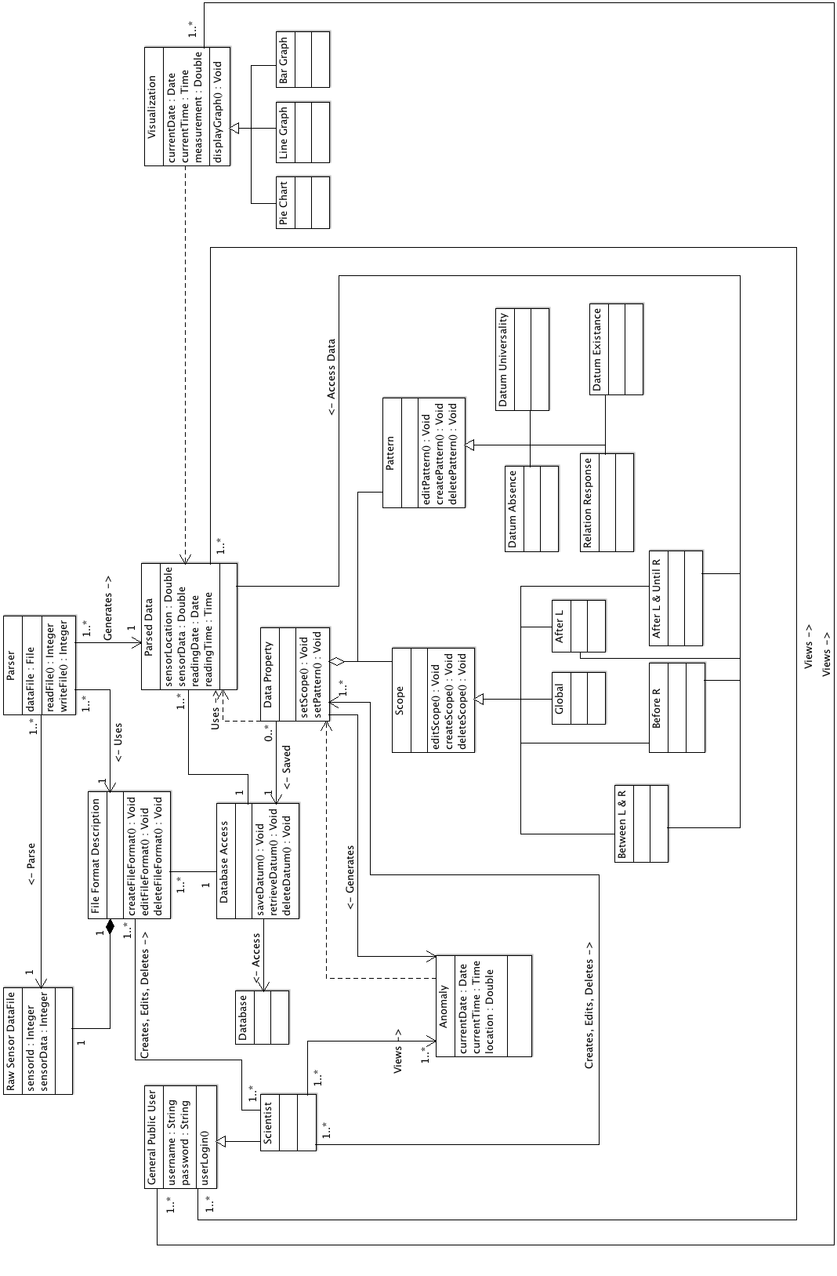

Appendix B State Chart
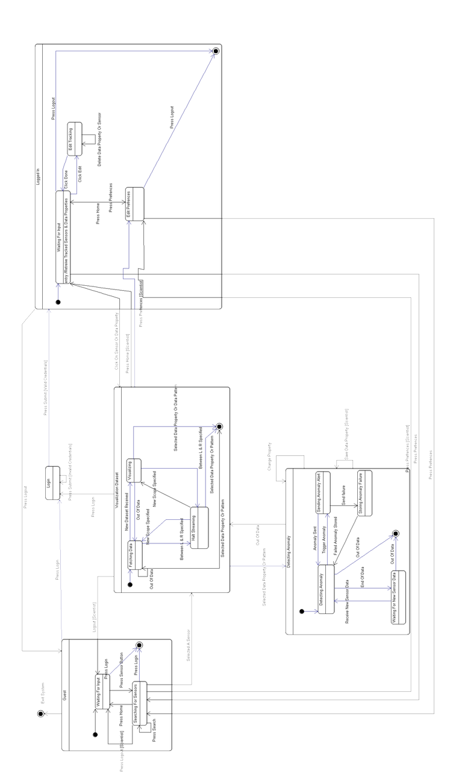

Appendix C Data Flow Diagram (DFD)




